

ICT Lab
BS CYFS 2025
Lab Task 12
Name: Ibrahim Bin Arif
Roll no: 2503541

Submitted to : Mrs. Laraib Javaid

Learning HTML:

Making a simple HTML Document:
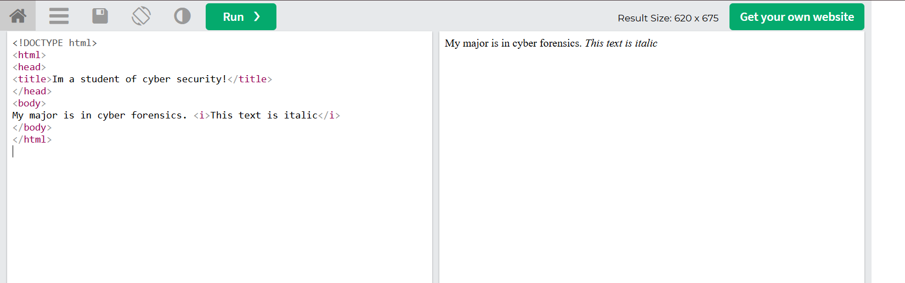
Using alignment tags:
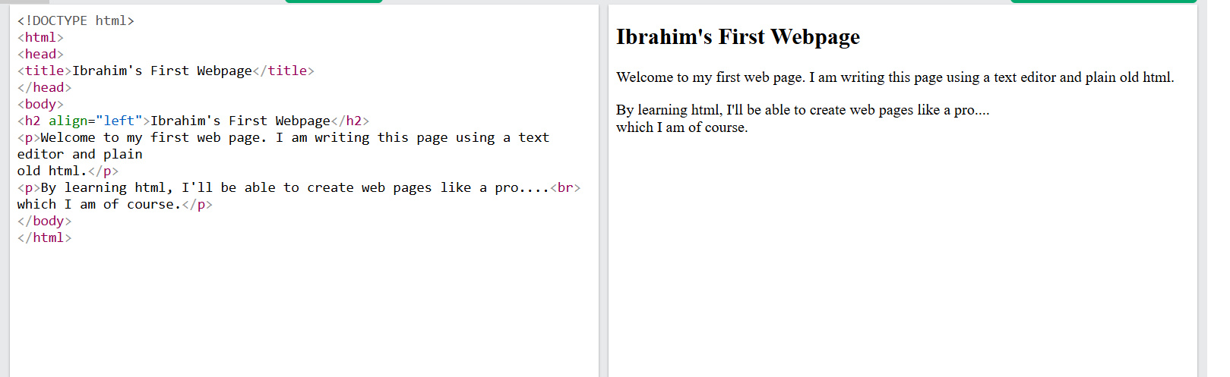
Using background colors in html:
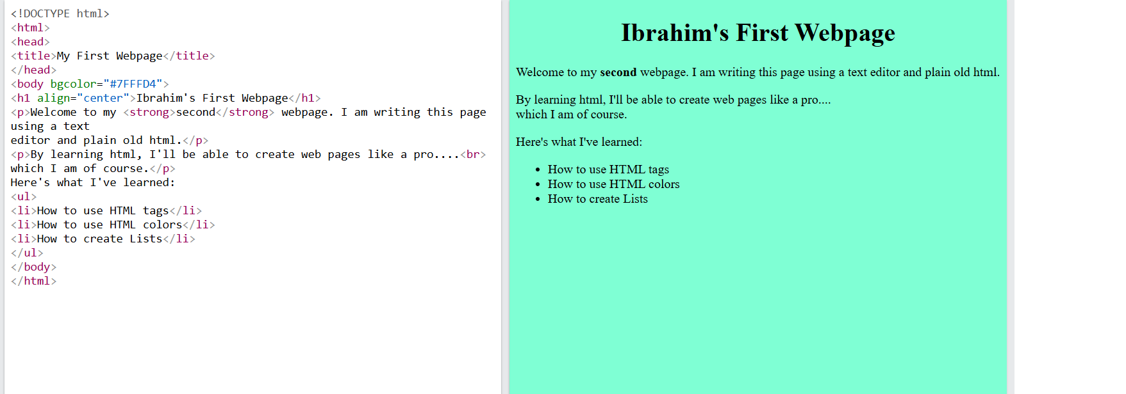
Inserting a picture:
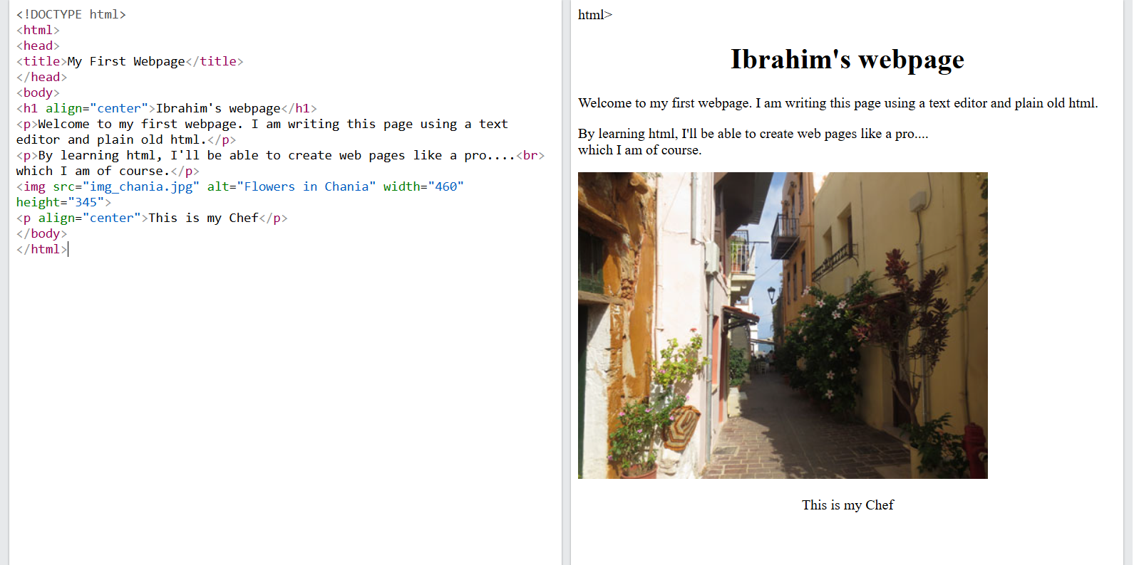

Now in the last task combing all that we have learned:
